1、product description：
The RD80 series radar sensor is a 26Ghz high frequency microwave pulse radar level gauge. An electromagnetic wave of about 11 mm is emitted through the radar antenna system, and reflection is formed on the material surface by focusing of the bell antenna. The reflected echo is received through the antenna system. Since the transmission speed of electromagnetic waves is equivalent to the speed of light, it is almost instantaneous to transmit to reception. The radar transmits and receives about 80 times per second. Through the microprocessor of the radar control system, the time difference of the transmitted wave to the received wave is accurately calculated by calculating the average value. The calculation of the internal software is used to convert the radar zero point to the material. The empty height of the bit. Thereby a continuous measurement of the material level is achieved. Output 4-20MA analog current signal, directly access to the automation system (such as PLC / DCS / digital display, etc.) to achieve automatic control of tank level.
Measurement diagram：
The radar level antenna transmits a narrower microwave pulse and is transmitted downward through the antenna. After the microwave contacts the surface of the measured medium, it is reflected back and received by the antenna system again. The signal is transmitted to the electronic circuit part and automatically converted into a level signal (because the microwave propagation speed is extremely fast, the electromagnetic wave reaches the target and is reflected back to the receiver. The time used is almost instantaneous). Millimeter wave radar. It has the characteristics of narrow antenna beam, high resolution, frequency bandwidth and strong anti-interference ability.
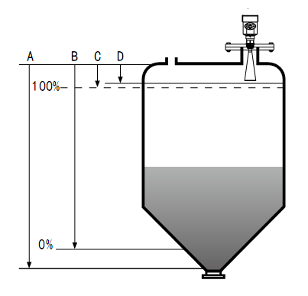

A Range setting

B Low adjustment

C High adjustment

D Blind zone

The reference plane for measurement is: the bottom surface of the thread or the sealing surface of the flange.
Note: When using the radar level timer, make sure that the highest level cannot enter the measurement dead zone (the area shown in D in the figure).。
26G radar level gauge features：
-  Small antenna size for easy installation; non-contact radar, no wear, no pollution。
-  Almost free from corrosion and foam; almost unaffected by changes in water vapor, temperature and pressure in the atmosphere。
-  Severe dust environment has little effect on the work of high frequency level gauge。
-  shorter wavelengths for better reflection on sloping solid surfaces。
-  The beam angle is small, the energy is concentrated, and the echo capability is enhanced while avoiding interference.。
-  The measurement blind zone is smaller, and it will also achieve good results for small can measurement.。
-  High signal-to-noise ratio for better performance even under fluctuating conditions。
-  High frequency, the best choice for measuring solid and low dielectric constant media。

2、Specifications

RD81
Application: Various corrosive liquids
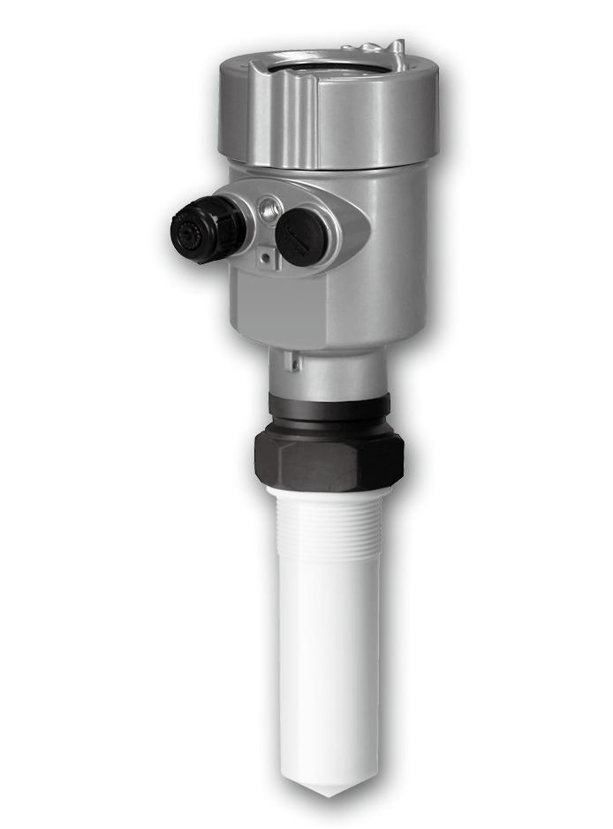
Measuring range: 20 meters
Process connection: thread, flange
Medium temperature: -40～120°C
Process pressure： -0.1～0.3MPa
Precision： ±5mm
Protection level： IP67
Frequency Range： 26GHz
Explosion-proof grade： Exib ⅡCT6 Gb
Signal output：4...20mA/HART(Two lines / four lines)
RS485/Mod bus

RD82
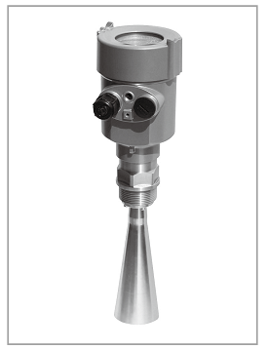
Application: Temperature, pressure, slightly corrosive liquid
Measuring range: 30 meters
Process connection: thread, flange
Medium temperature： -40～150℃
Process pressure： -0.1～4.0MPa
Accuracy： ±3mm
Protection level： IP67
Frequency Range： 26GHz
Explosion-proof grade： Exib ⅡCT6 Gb
Signal output：4...20mA/HART(Two lines / four lines) RS485/Mod bus

RD83
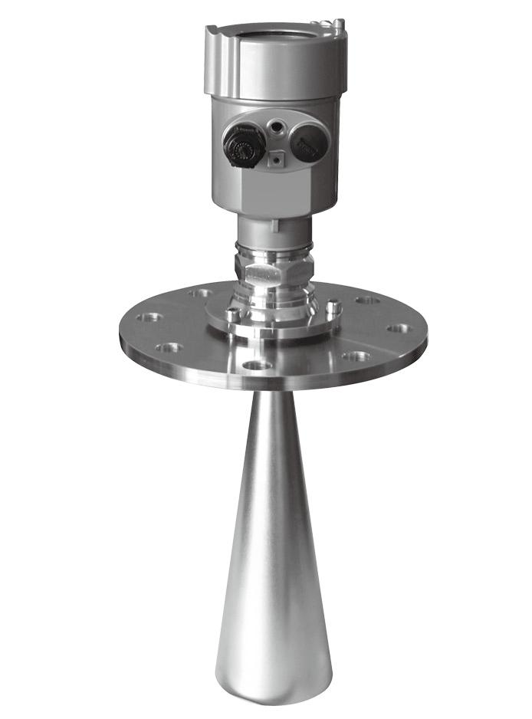
Application: Solid material, strong dust, easy to crystallize, condensation occasion
Measuring range: 70 meters
Process connection: universal flange
Medium temperature： -40～250℃
Process pressure： -0.1～0.1MPa
Accuracy： ±15mm
Protection level： IP67
Frequency Range： 26GHz
Explosion-proof grade： Exib ⅡCT6 Gb
Signal output：4...20mA/HART(Two lines / four lines)
RD84
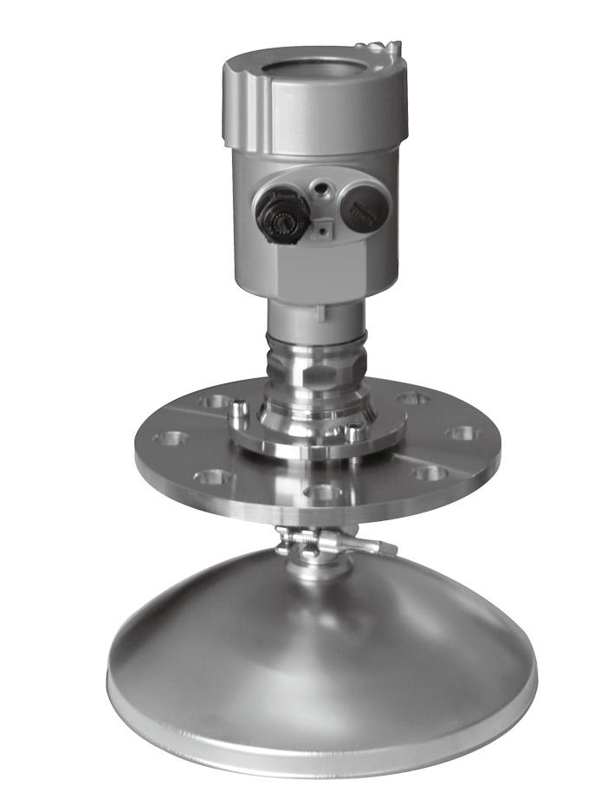
Application: Solid material, strong dust, easy to crystallize, condensation occasion
Measuring range: 70 meters
Process connection: universal flange
Medium temperature： -40～250℃
Process pressure： -0.1～0.1MPa
Accuracy： ±15mm
Protection level： IP67
Frequency Range： 26GHz
Explosion-proof grade： Exib ⅡCT6 Gb
Signal output：4...20mA/HART(Two lines / four lines)
RS485/Mod bus
RD85
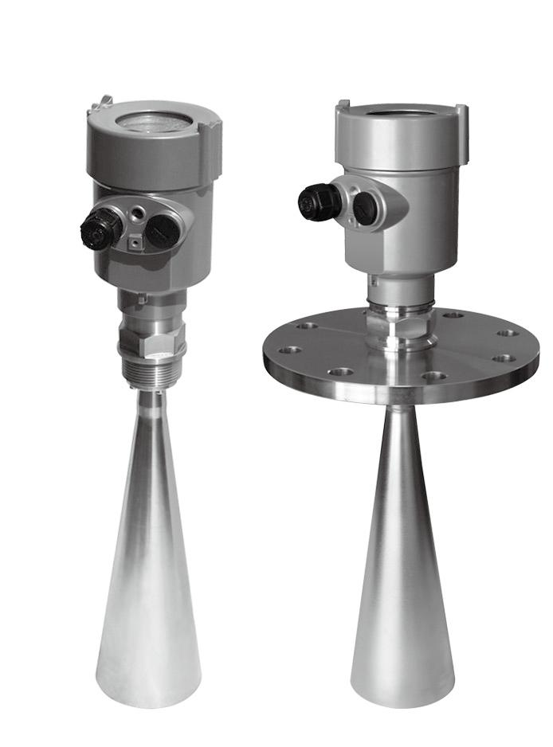
Application: solid particles, powder
Measuring range: liquid 30 m / solid block 20 m / solid powder 15 m
Process connection: thread, flange
Medium temperature： -40～250℃
Process pressure： -0.1～4.0MPa(Flat flange)
-0.1～0.1MPa（Universal flange）
Accuracy： ±10mm
Protection level： IP67
Frequency Range： 26GHz
Explosion-proof grade： Exib ⅡCT6 Gb
Signal output：4...20mA/HART(Two lines / four lines)
RS485/Mod bus
RD86
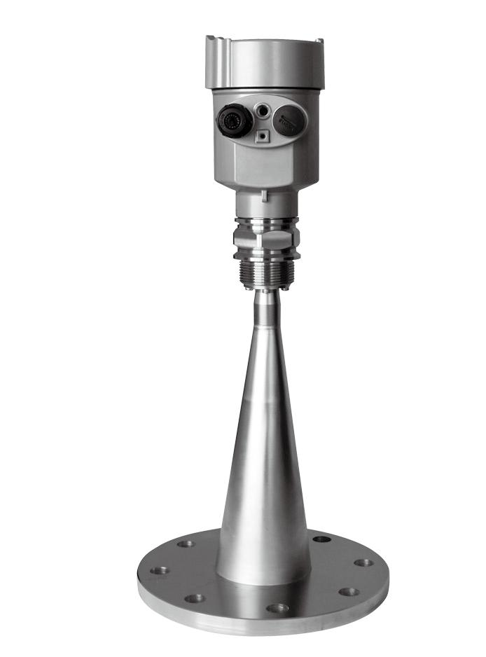
Application: Hygienic liquid storage container, strong corrosive container
Measuring range: 20 meters
Process connection: flange
Medium temperature： -40～150℃
Process pressure： -0.1～0.1MPa
Accuracy： ±3mm
Protection level： IP67
Frequency Range： 26GHz
Explosion-proof grade： Exib ⅡCT6 Gb
Signal output：4...20mA/HART(Two lines / four lines)
RS485/Mod bus

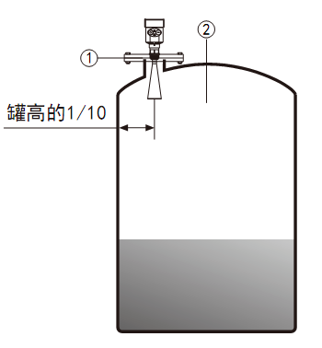
3、Installation requirements
-  Installation instructions

Installed at 1/4 or 1/6 of the diameter.

Note: The minimum distance from the tank wall
should be 1/10 of the tank height.
Note: 1 datum 2 container center or axis of symmetry

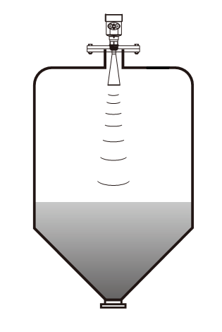
- The top surface of the conical tank can be placed
in the middle of the tank top.
It is guaranteed to measure the bottom of the cone.

When there is a material pile, the antenna should be aligned perpendicular to the material surface. If the material
Uneven, large stack angle must use universal flange to adjust the angle of the horn
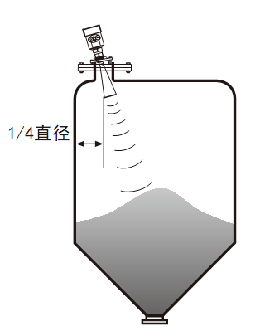
Make the horn as close as possible to the finish.

(Because the inclined solid surface causes echo attenuation,
Even the problem of losing the signal)

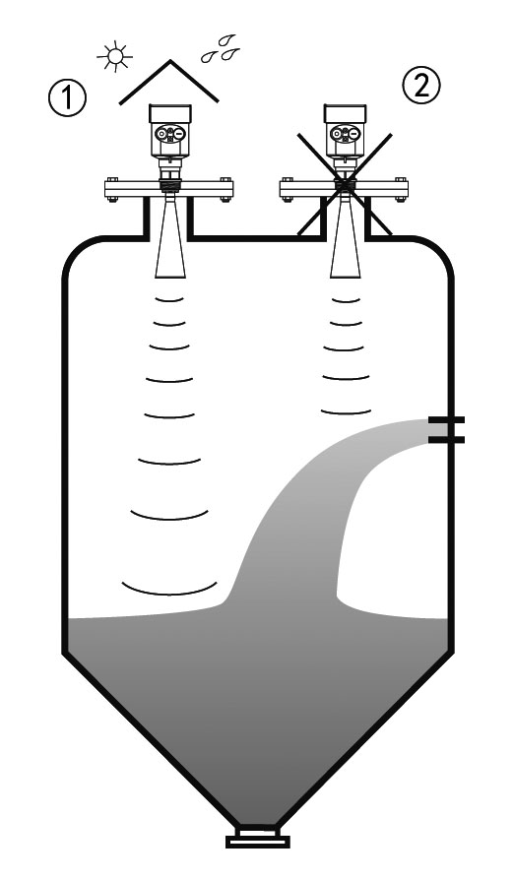
- Typical error installation：

Conical tanks cannot be installed above the inlet.
At the same time, attention should be paid: sun protection and rain protection measures should be taken during outdoor installation.

- correct ②error

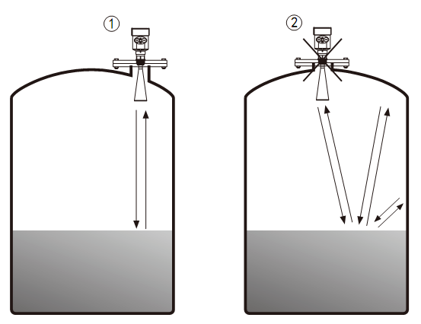
- The meter cannot be installed in the middle of an arched or rounded tank top. In addition to generating indirect echoes, it is also affected by multiple echoes. Multiple echoes may be larger than the true echo signal threshold because multiple echoes can be concentrated through the top. So can't be installed in the center。

①correct ②error

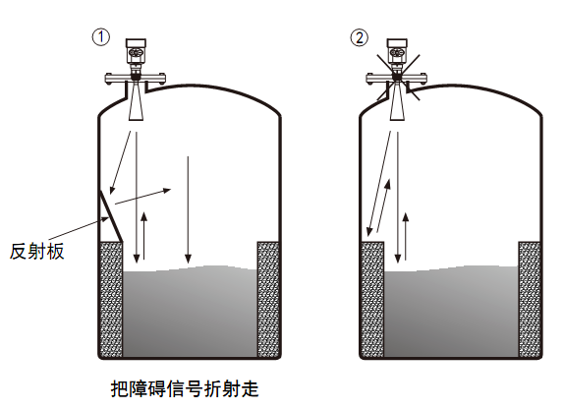
- When there are obstacles in the tank that affect the measurement, a reflector should be added to measure normally.

①correct ②error

- Take-over height requirements: The antenna must be inserted into the tank at least 10 mm away。
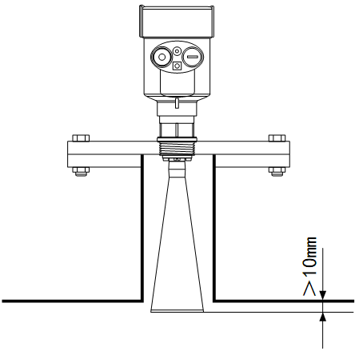

4、Electrical connections
-  Power supply voltage
(4~20) mA/HART (two-wire system) The power supply and output current signals share a two-core shielded cable. See the technical data for the specific supply voltage range. For intrinsically safe type, a safety barrier must be added between the power supply and the meter.

4~20) mA/HART (4-wire system) The power supply and current signals are separated, and each cable is used separately. See the technical data for the specific supply voltage range.

RS485/Modbus A separate shielded cable is used for each of the power supply and Modbus signal lines. See the technical data for the specific supply voltage range.

- Connection method

24V The two-wire wiring diagram is as follows：

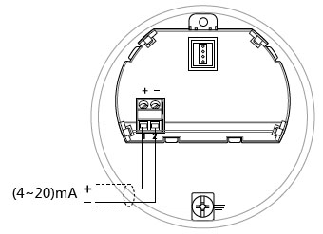

220V Four-wire wiring as shown below：

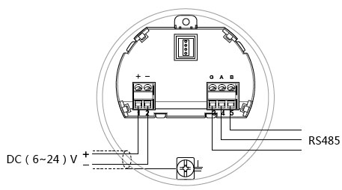
24V RS485/Modbus Wiring diagram is as follows：

- Safety guidance
Please observe the requirements of the local electrical installation regulations!
Please observe local regulations regarding the health and safety of personnel. All operations on the electrical components of the instrument must be performed by trained professionals.
Please check the nameplate of the instrument to ensure that the product specifications meet your requirements. Make sure that the supply voltage is the same as that on the instrument nameplate.
- Protection level
The instrument fully meets the requirements of protection class IP66/67, please ensure the waterproofness of the cable gland. As shown below：
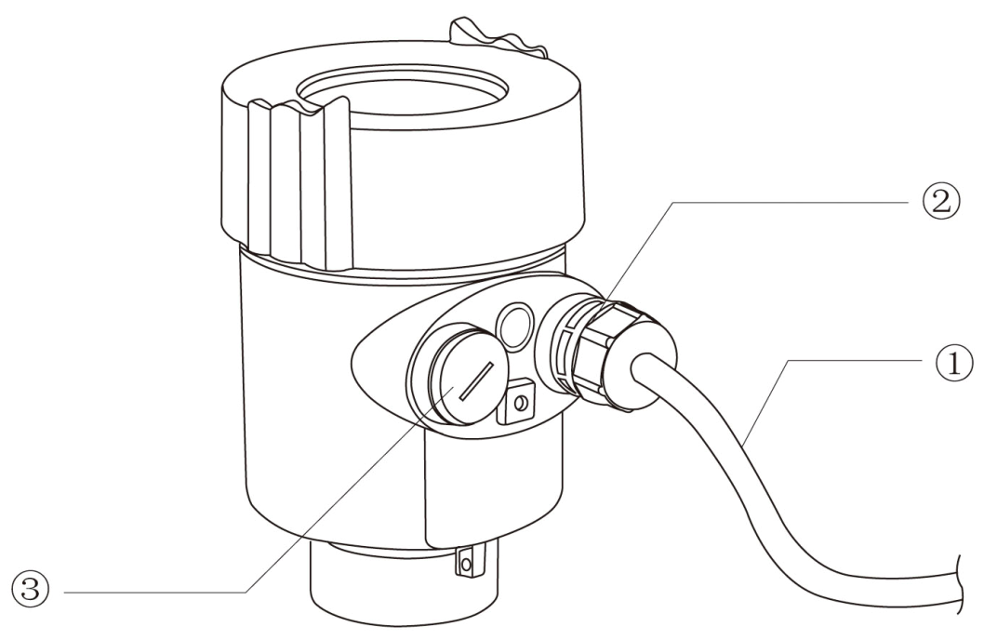

How to ensure that the installation meets the requirements of IP67:
Make sure the seal head is not damaged.
Make sure the cable is not damaged.
Make sure that the cable you are using meets the electrical connection specifications.
Before entering the electrical interface, bend the cable down to ensure that water does not flow into the housing, see 1
Please tighten the cable gland, see 2
Please block the unused electrical interface with a blind plug, see 3
5、Instrument debugging
- Three debugging methods：
- Display/button
- Host computer debugging
- HART handheld programmer
- Display/button
The instrument is debugged by the four buttons on the display screen. The language of the debug menu is optional. After commissioning, it is generally only used for display. The measured value can be read very clearly through the glass window.
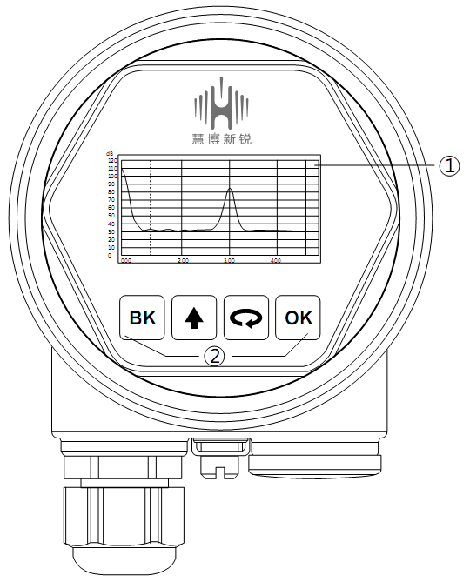

Display/button

- LCD
- button

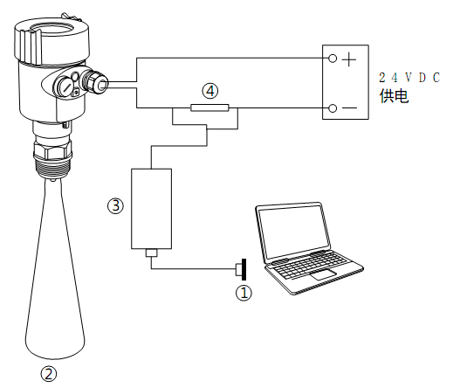
- Host computer debugging
Connected to the host computer via HART

① RS232 interface / or USB interface
② Radar level gauge
③ HART adapter
④ 250Ω resistor

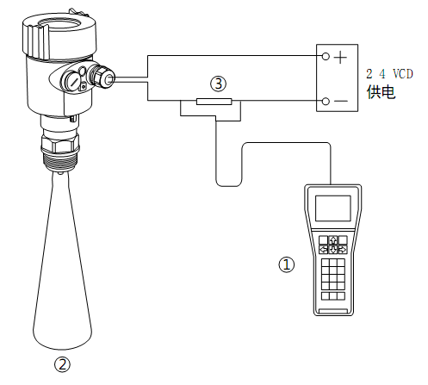
- HART handheld programmer programming

① HART handheld programmer
② RD90XRadar level gauge
③ 250Ω resistor

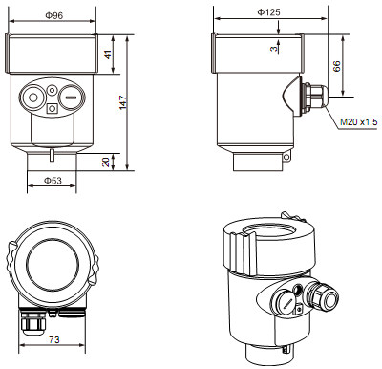
6、Structure Size （unit： mm）

- Case

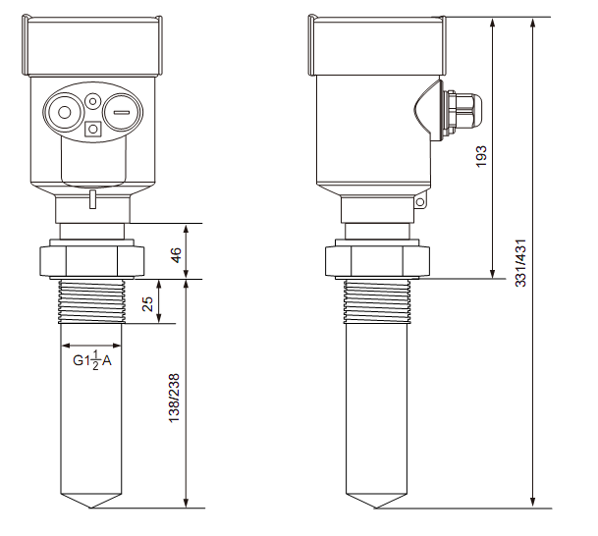
- Physical Dimension
RD81

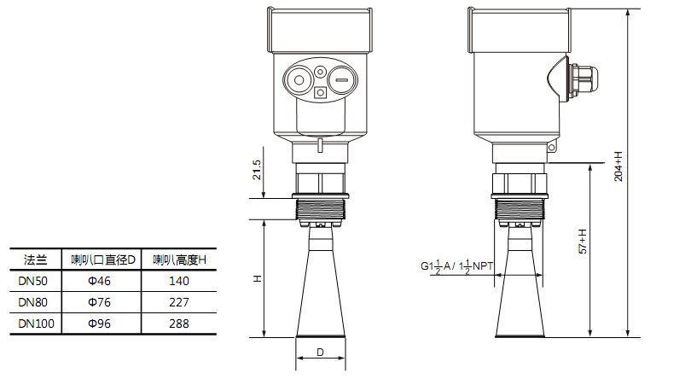
RD82

RD83
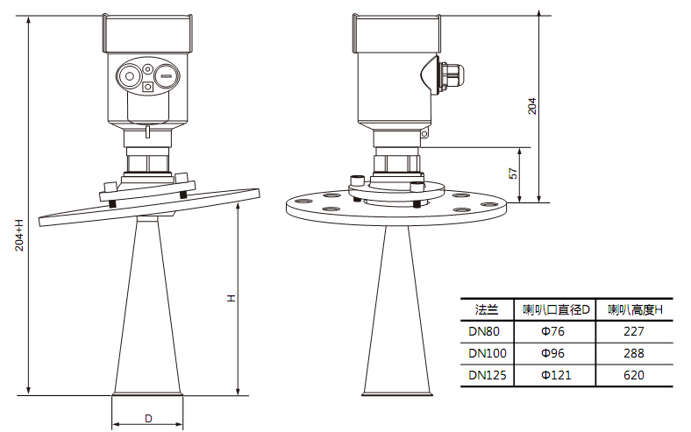

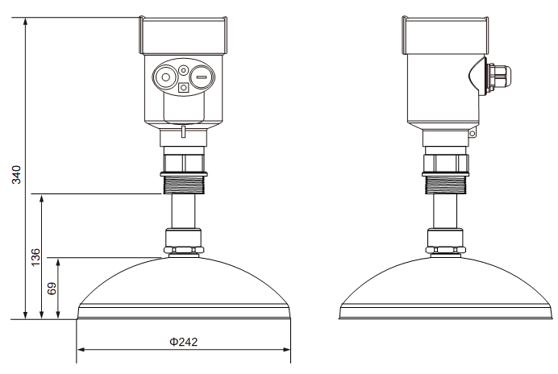
RD84

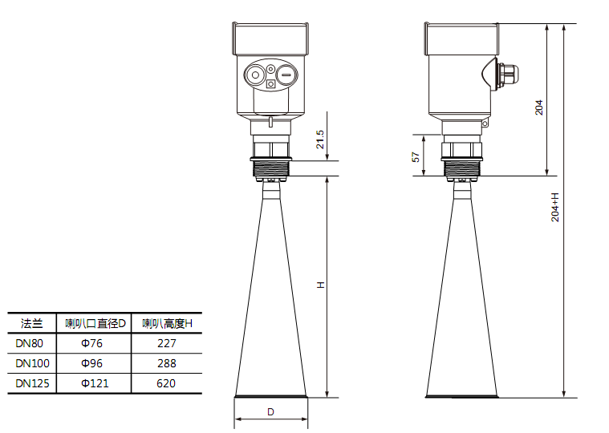
RD85

RD86
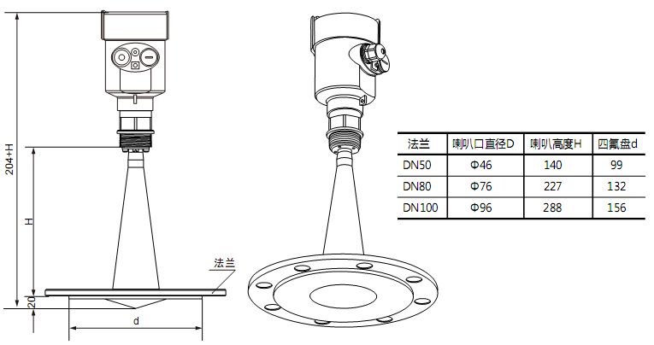

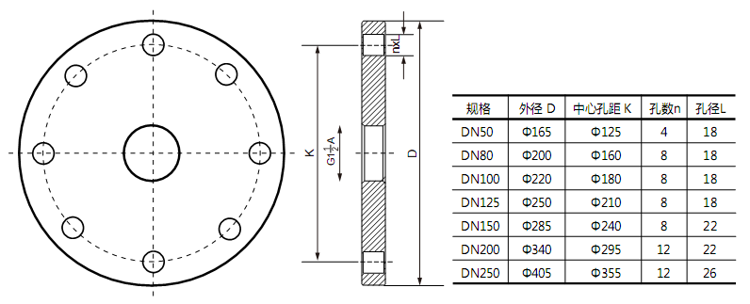
- Flange selection

7、技术参数
Shell
Seal between the outer casing and the outer casing cover Silicone Rubber
Shell window Polycarbonate
Ground terminal stainless steel

Supply voltage
Two-wire system Standard type (16～26) V DC
Intrinsically safe (21. 6～26. 4) V DC
Power consumption max 22. 5mA / 1W
Allow ripple
- <100Hz Uss<lV
- (100～100K) Hz Uss<l0mV

Cable parameter
Cable entry/plug M20xl.5 Cable entry
Terminals Wire cross section 1.0mm²

Output parameters
output signal (4～2 0) mA
Protocol HART
Resolution 1. 6u A
Fault signal Current output is unchanged；20. 5mA
22mA；3.9mA
Integration time (0～50)s，Adjustable

Blind zone Antenna end
Maximum measurement distance 70 meters
Microwave frequency 26GHz
Communication Interface HART Protocol
Measurement interval About 1 second (depending on parameter settings)
Adjust the time About 1 second (depending on parameter settings)
display resolution 1mm
Working storage and transportation temperature (-40～100) ℃
Process temperature (temperature of the antenna section) (-40～250)℃

pressure Max. 4MPa
Shockproof Mechanical vibrationl0m/s² , (10～150)Hz

8、Instrument Linear

RD81
Launch angle 20°
Precision See below
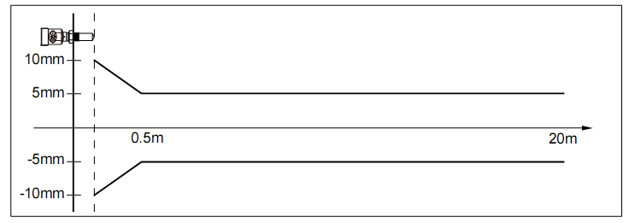

RD82
Launch angle Depending on the antenna size
-￠46mm 18°
-￠76mm 12°
-￠96mm 8°
Precision See below
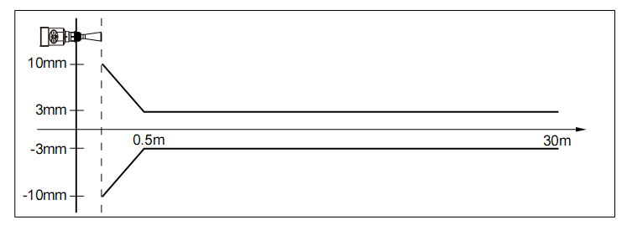

RD83
Launch angle Depending on the antenna size
-￠76mm 12°
-￠96mm 8°
-￠121mm 6°
Precision See below
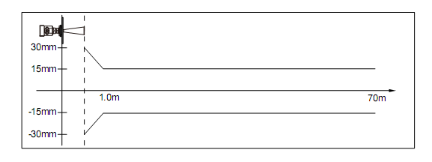

RD84
Launch angle Depending on the antenna size
-￠196mm 4°
-￠242mm 4°
Precision See below
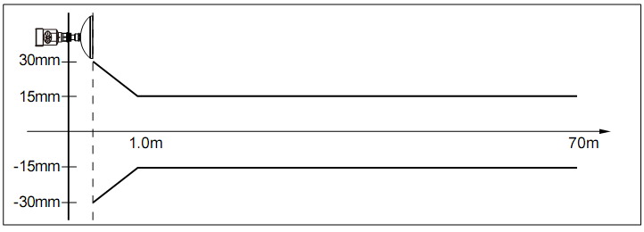

RD85
Launch angle Depending on the antenna size
-￠76mm 12°
-￠96mm 8°
-￠121mm 6°
Precision See below
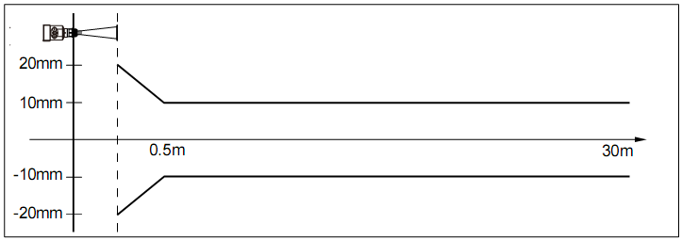

RD86
Launch angle Depending on the antenna size
-￠46mm 18°
-￠76mm 12°
-￠96mm 8°
Precision See below

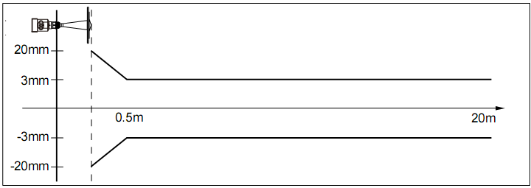

9、Instrument Selection Table
- RD81
license
P Standard type (non-explosion proof)
I Intrinsically safe (Exib IIC T6 Gb)
D Intrinsically safe type + explosion-proof type (Exd [ib] ib IIC T6 Gb)
Antenna type / material / process temperature
F Sealed horn / PTFE (-40~120℃)
Process connection/material
G Thread G1½″ A
N Thread 1½″ NPT
A Flange DN50/PP
B Flange DN80/PP
C Flange DN100/PP
Y Special custom
Container take-up length
A take over 100mm
B take over 200mm
Electronic unit
2 （4~20）mA/24V DC Two-wire system
3 （4~20）mA/24V DC/HART Two-wire system
4 （4~20）mA/220V AC/ Four-wire system
5 RS485/Modbus
Enclosure rating
L aluminum /IP67
G stainless steel 304/IP67
Cable entry
M M20 x l. 5
N ½ ″NPT
Live display/programming
A band X Without

- RD82
license
P Standard type (non-explosion proof)
I Intrinsically safe (Exib IIC T6 Gb)
D Intrinsically safe type + explosion-proof type (Exd [ib] ib IIC T6 Gb)
Process connection/material
G Thread G1½″ A/ stainless steel 304
N Thread 1½″ NPT/ stainless steel 304
A Flange DN50/ stainless steel 304
B Flange DN80/ stainless steel 304
C Flange DN100/ stainless steel 304
Y Special custom
Antenna type / material
A Horn antenna Φ46mm/ stainless steel 304
B Horn antenna Φ76mm/ stainless steel 304
C Horn antenna Φ96mm/ stainless steel 304
Y Special custom
Seal / process temperature
V Viton/（-40~150） ℃
K Kalrez/（-40~250） ℃
Electronic unit
2 （4~20）mA/24V DC Two-wire system
3 （4~20）mA/24V DC/HART Two-wire system
4 （4~20）mA/220V AC/ Four-wire system
5 RS485/Modbus
Enclosure rating
L aluminum /IP67
G stainless steel 304/IP67
Cable entry
M M20 x l. 5
N ½ ″NPT
Live display/programming
A band
X Without

- RD83
license
P Standard type (non-explosion proof)
I Intrinsically safe (Exib IIC T6 Gb)
D Intrinsically safe type + explosion-proof type (Exd [ib] ib IIC T6 Gb)
Process connection/material
G Thread G1½″ A/ stainless steel 304
N Thread 1½″ NPT/ stainless steel 304
B Thread DN80/ stainless steel 304
C Thread DN100/ stainless steel 304
D Thread DN125/ stainless steel 304
E Thread DN150/ stainless steel 304
F Thread DN200/ stainless steel 304
H Thread DN250/ stainless steel 304
M Thread DN80/ Universal joint / Carbon steel nickel plating
K Thread DN100/ Universal joint / Carbon steel nickel plating
T Thread DN125/ Universal joint / Carbon steel nickel plating
Z Thread DN150/ Universal joint / Carbon steel nickel plating
W Thread DN200/ Universal joint / Carbon steel nickel plating
V Thread DN250/ Universal joint / Carbon steel nickel plating
Y Special custom
Antenna type / material
B Horn antenna Φ76mm/ stainless steel 304
C Horn antenna Φ96mm/ stainless steel 304
D Horn antenna Φ121mm/ stainless steel 304
Seal / process temperature
V Viton/（-40~150） ℃
K Kalrez/（-40~250） ℃
Electronic unit
2 （4~20）mA/24V DC Two-wire system
3 （4~20）mA/24V DC/HART Two-wire system
4 （4~20）mA/220V AC/ Four-wire system
5 RS485/Modbus
Enclosure rating
L aluminum /IP67
G stainless steel 304/IP67
Cable entry
M M20 x l. 5
N ½″ NPT
Live display/programming
A band X Without

- RD84
license
P Standard type (non-explosion proof)
I Intrinsically safe (Exib IIC T6 Gb)
D Intrinsically safe type + explosion-proof type (Exd [ib] ib IIC T6 Gb)
Process connection/material
G Thread G1½″ A/ stainless steel 304
N Thread 1½″ NPT/ stainless steel 304
B Thread DN80/ stainless steel 304
C Thread DN100/ stainless steel 304
D Thread DN125/ stainless steel 304
E Thread DN150/ stainless steel 304
F Thread DN200/ stainless steel 304
H Thread DN250/ stainless steel 304
M Thread DN80/ Universal joint / carbon steel nickel plating
K Thread DN100/ Universal joint / carbon steel nickel plating
T Thread DN125/ Universal joint / carbon steel nickel plating
Z Thread DN150/ Universal joint / carbon steel nickel plating
W Thread DN200/ Universal joint / carbon steel nickel plating
V Thread DN250/ Universal joint / carbon steel nickel plating
Y Special custom
Antenna type / material
B Parabolic antenna Φ196mm/ stainless steel 304
C Parabolic antenna Φ242mm/ stainless steel 304
Seal / process temperature
V Viton/（-40~150） ℃
K Kalrez/（-40~250） ℃
Electronic unit
2 （4~20）mA/24V DC Two-wire system
3 （4~20）mA/24V DC/HART Two-wire system
4 （4~20）mA/220V AC/ Four-wire system
5 RS485/Modbus
Enclosure rating
L aluminum /IP67
G stainless steel 304/IP67
Cable entry
M M20 x l. 5
N ½″ NPT
Live display/programming
A band X Without

- RD85
license
P Standard type (non-explosion proof)
I Intrinsically safe (Exib IIC T6 Gb)
D Intrinsically safe type + explosion-proof type (Exd [ib] ib IIC T6 Gb)
Process connection/material
G Thread G1½″ A/ stainless steel 304
N Thread 1½ ″NPT/ stainless steel 304
B Flange DN80/ stainless steel 304
C Flange DN100/ stainless steel 304
D Flange DN125/ stainless steel 304
E Flange DN150/ stainless steel 304
F Flange DN200/ stainless steel 304
H Flange DN250/ stainless steel 304
M Flange DN80/ Universal joint / carbon steel nickel plating
K Flange DN100/ Universal joint / carbon steel nickel plating
T Flange DN125/ Universal joint / carbon steel nickel plating
Z Flange DN150/ Universal joint / carbon steel nickel plating
W Flange DN200/ Universal joint / carbon steel nickel plating
V Flange DN250/ Universal joint / carbon steel nickel plating
Y Special custom
Antenna type / material
B Horn antenna Φ76mm/ stainless steel 304
C Horn antenna Φ96mm/ stainless steel 304
D Horn antenna Φ121mm/ stainless steel 304
Seal / process temperature
V Viton/（-40~150） ℃
K Kalrez/（-40~250） ℃
Electronic unit
2 （4~20）mA/24V DC Two-wire system
3 （4~20）mA/24V DC/HART Two-wire system
4 （4~20）mA/220V AC/ Four-wire system
5 RS485/Modbus
Enclosure rating
L aluminum /IP67
G stainless steel 304/IP67
Cable entry
M M20 x l. 5
N ½ ″NPT
Live display/programming

- RD86
license
P Standard type (non-explosion proof)
I Intrinsically safe (Exib IIC T6 Gb)
D Intrinsically safe type + explosion-proof type (Exd [ib] ib IIC T6 Gb)
Process connection/material
B Flange DN80/ stainless steel 304
C Flange DN100/ stainless steel 304
D Flange DN125/ stainless steel 304
E Flange DN150/ stainless steel 304
F Flange DN200/ stainless steel 304
Y Special custom
Antenna type / material
B Horn antenna Φ46mm/ stainless steel 304
C Horn antennaΦ76mm/ stainless steel 304
D Horn antenna Φ96mm/ stainless steel 304
Seal / process temperature
V Viton/（-40~150） ℃
Electronic unit
2 （4~20）mA/24V DC Two-wire system
3 （4~20）mA/24V DC/HART Two-wire system
4 （4~20）mA/220V AC/ Four-wire system
5 RS485/Modbus
Enclosure rating
L aluminum/IP67
G stainless steel 304/IP67
Cable entry
M M20 x l. 5
N ½″ NPT
Live display/programming
A band X Without

10、Level gauge Parameter List
Customer Information
Unit： Contact：
Address： postal code：
Telephone： Fax： Mobile phone：
Mail box： Date: year month day
许可证
□ Intrinsically safe（Exib IIB T5） □ Intrinsically safe（Exib IIC T6 Gb）
□ Standard type (non-explosion proof) □ 本安型+船用许可证（Exib IIC T6 Gb）
□ Intrinsically safe type + explosion-proof type（Exd [ ib ] IIC T6 Gb）
Tank/container information
Tank type：
□Storage tank □Reaction tank □Separation tank □Marine storage tank
Tank structure：
Tank size： Tank material： Pressure：
Tank height： m diameter： m
Tank top： □Vaulted □Flat top □Open type □Cone top
Tank bottom： □Cone bottom □flat □Slope bottom □Curved bottom
installation： □Top mounting □Side mounting
□Bypass pipe installation □Waveguide installation
Tank top installation takeover (important information)：
Takeover height mm ；Take-up diameter mm
Measuring medium
Media Name： □liquid □solid □Mixed medium
Medium temperature： ℃ Dielectric constant：
Hanging material： □Yes □no
Stir： □Yes □no
Process connection
Thread：（□ G1½A □ 1½NPT ） Flange（DN= ） Flange（ANSI= ）
power supply：
□ 24V DC Two-wire system □ 24V DC Four-wire system □ 220V AC Four-wire system
Output： □ 4-20mA □ HART
display： □With head display programming □Programming without header display

